Library Name: | cgm
Cell Name: | XOR2XI
Function/Truth Table:
A B |  | Y
0 0 |  | 0
0 1 |  | 1
1 0 |  | 1
1 1 |  | 0
Propagation Delay (path based):
Transition |  | Delay (s)
A → Y ↑ (T_PLH) |  | 1.397n
A → Y ↓ (T_PHL) |  | 1.679n
B → Y ↑ (T_PLH) |  | 1.398n
B → Y ↓ (T_PHL) |  | 1.675n
Output Rise Time (path based):
Transition |  | Rise Time (s)
A → Y ↑ |  | 2.7n
B → Y ↑ |  | 2.68n
Output Fall Time (path based):
Transition |  | Fall Time (s)
A → Y ↓ |  | 3.226n
B → Y ↓ |  | 3.204n
Layout Height: 1.71µm
Layout Width: 2.2µm
Layout Area: 3.762µm
Symbol with Port Names:

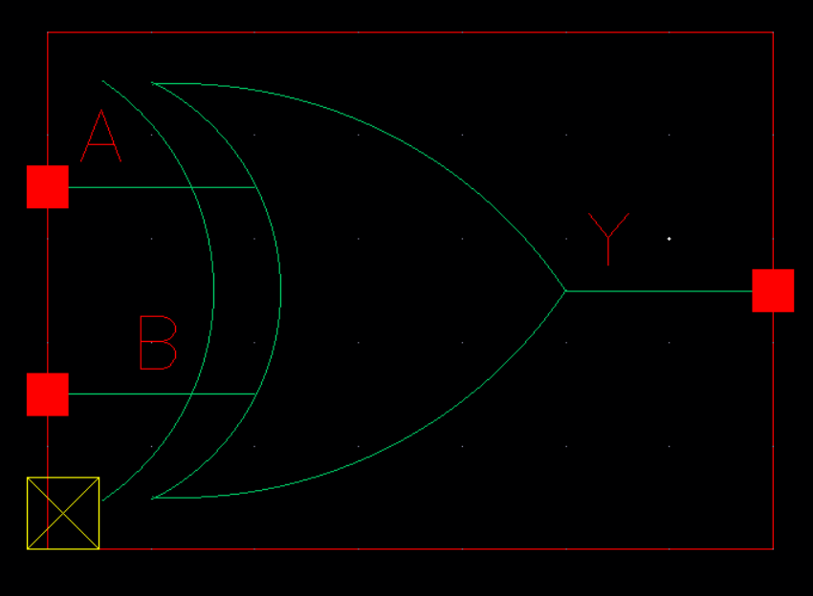
Schematic:

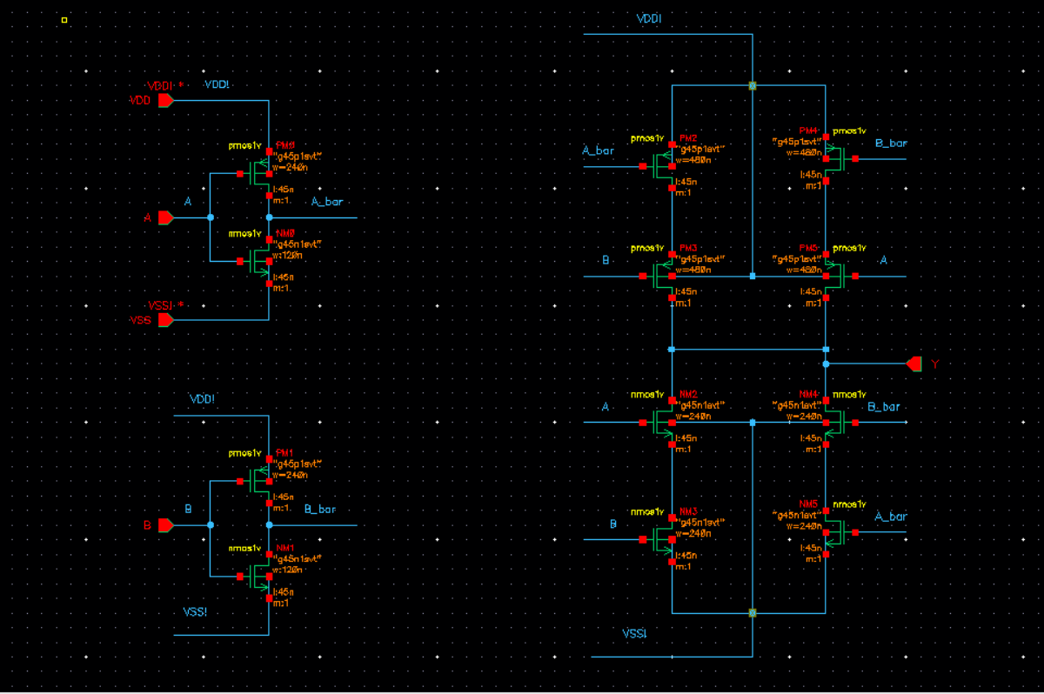
Layout:

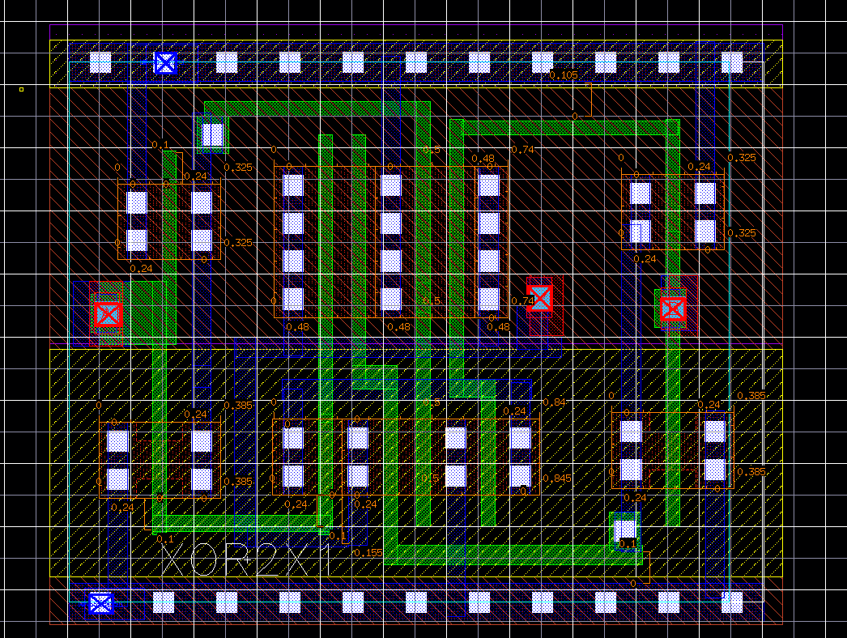
Functional Simulation Waveforms

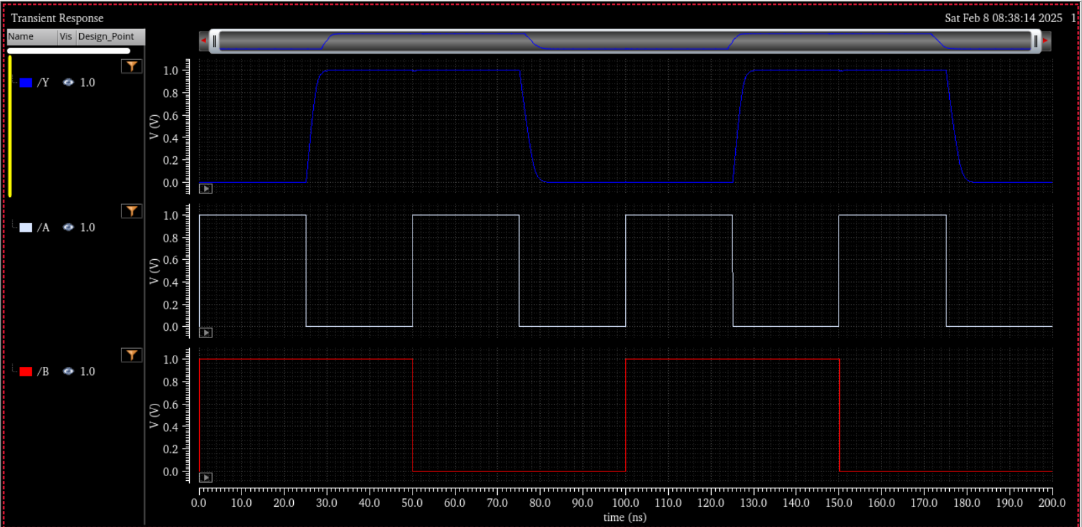

Comments/Notes:

The XOR2X1 gate was successfully tested, confirming correct functional verification. The propagation delays remain within acceptable limits, with slight variations due to extracted parasitics. Compared to the pre-layout results, rise times have increased, while fall times have slightly improved, indicating the influence of interconnect capacitances and transistor sizing. Functional simulation verified correct logic operation, ensuring the gate meets performance requirements for integration into larger circuit designs.

